Experiment-5

1.Create schema college



2.Create table-student and attributes are studid,studname,gender,subject,marks,grade

3.Create table-Faculty and attributes are fac_id,fac_name,course,pass percentage

4.Create table-department and attributes are dept_no,dept_name,section,no of students,pass percentage

5.Create table-Activity and attributes are act_id,act_name,no of students opted ,category of activity

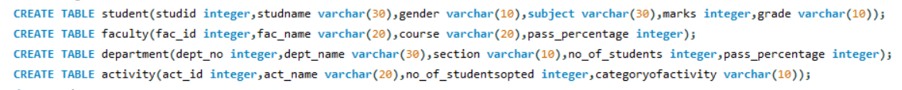

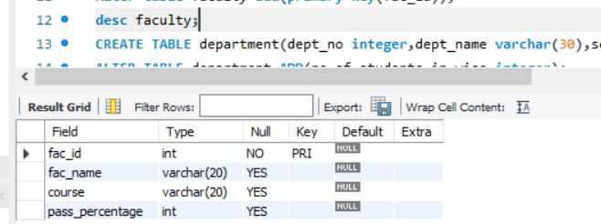

Student table:

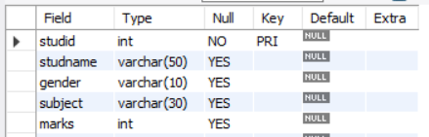

1.Add address in student table,change the datatype size for student name and make studid as primary key

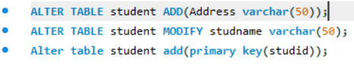

2.Add faculty total mentor details,make fac_id as primary key



3.Add no of students in wise and make dept no as primary key



4.Add faculty name and change the size of act_name and act_id as primary key

